PARISH NEWS
The Deverills & Crockerton

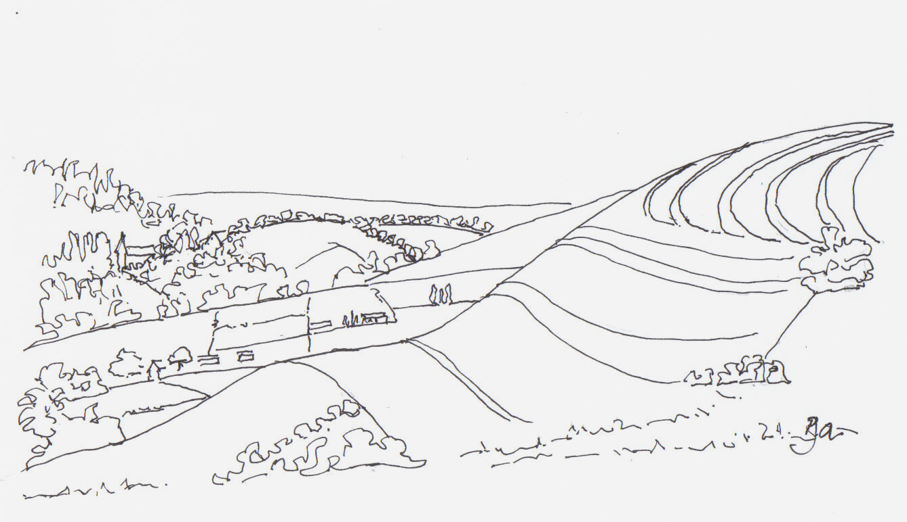

From Lords Hill towards Longbridge Deverill
By
Pat Armstrong
February 2010

Look inside for local information

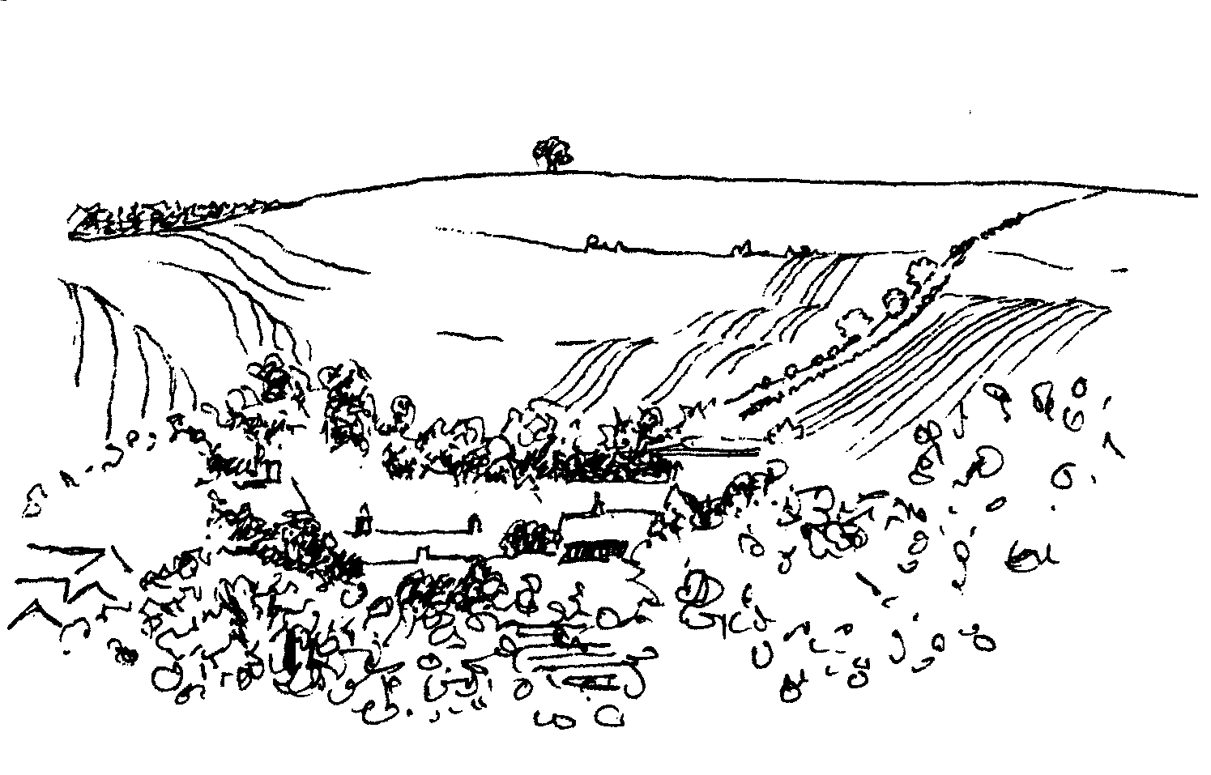
-2-

Deverill Valley & Crockerton Women's Institute
Longbridge Deverill Hall

Monday 8th February 7.30 pm
‘Here we go a-vicaring’
by Rev Mary Teed
Social time: Car quiz

For more information contact Jill Russell 840209

Longbridge Deverill Village Hall

Pancake evening

Tuesday 16th February 5.00 - 7.00 pm
Tickets £3.00, Children £1.50

Baked potatoes: various fillings
and Pancakes!

For more information
contact Janet Budgen 218203 or Pat Wood 840535

Coffee, Cards and Chat
Come and enjoy looking at the new range of cards,
ribbons, wrapping paper, and other exciting items
displayed by John and Maddie Goodden
in the Upper Deverills Village Hall on Thursday 19th February
between 10.30 and 12.00 noon - everyone is welcome
Donations will be made to the hall and the church

Salisbury Theatre Club Trips
Monday 15th February
Private Lives by Noel Coward
Monday 15th March
The Glass Menagerie by Tennessee Williams
Monday 19th April
Low pay? Don’t pay! by Dario Fo
Monday 17th May
Les Liaisons Dangereuses by Christopher Hampton
The cost is £17.00: theatre seat £12.00 and coach trip £5.00
Please book early to ensure tickets, payment in advance to Mary Stewart Cox
Tel 840877 at Longmead, Brixton Deverill, Warminster BA12 7EJ
Coach leaves Kingston Church 6.10 pm and collects through the Deverills
Performances begin at 7.30 pm

-3-
The Rector writes:
Twice in the past week, I have been taken aback by statistics I have read. They appeared in very different situations, but had a significant impact. The first was the statement that people with bank accounts are among the richest 8% of the world's population. The second, on a similar theme, was this: 'I am a working class woman from the UK, two pay packets away from disaster, like so many. I did not think I was in the richest 10% of the world.' (quoted in a letter from Christian Aid). My thinking about how fortunate my situation is has as its background the situation in Haiti, following the recent earthquake, and the regular updates about the situation of fragile peace in Sudan, and in particular our Benefice support of the secondary school in Juba.
I have been very aware, during the recent bad weather, of the way our communities have pulled together to help and look out for the vulnerable. All sorts of kindnesses have been offered and accepted. There has been a very real sense of care and concern. It isn't always easy to extend that care beyond our immediate circles, but with the season of Lent beginning in the middle of February (17th), it is an ideal time to look again at what we might be able to do to help those not so fortunate as we are - those who do not find themselves in the most affluent 10% of the world's population.
Christian Aid produces a useful resource to help in this challenge. It is called 'Count your Blessings'. It takes account of the days of Lent and offers a daily challenge, thought or action to highlight much of what we take for granted. Do pick up a 'Count your Blessings' leaflet from one of the churches. It makes interesting reading if nothing else. But hopefully you may allow yourself to be challenged, to count your blessings and in so doing, help those in the poorest places in the world.
May your journey through Lent be richly blessed.
Norma Payne
Lent Lunches for ‘Wateraid’
There will be four ‘Church mouse lunches’ (soup, bread and cheese) during Lent, between 12.00 and 2.00 pm:
Thursday 25th February at Judy Munro’s (844385) Whitepits Lodge, Kingston Thursday 4th March, at Mary Royall’s (840338) Sandhill Lodge, Longbridge Thursday 11th March, at Marie Poole’s (840902) 7 Homefields, Longbridge. Thursday 18th March, venue is to be decided. Come along to share fellowship and help raise funds for this life giving and vital charity.
Lent discussion Groups
The Lent discussion groups will take place within the villages during March and will focus on material from the ‘Fully Alive’ course. The venues will be: the Munros (844385) Whitepits Lodge, Kingston; the Budgens (218203) Woodlands, Sutton End, Crockerton and another, yet to be confirmed. It is hoped you will be able to go along and participate in the group local to you; we look forward to you joining us.

-4-
Annual Revision of the Church Electoral Roll
As in previous years the PCC of Horningsham and the Deverills is required to conduct an annual revision of the Church Electoral Roll in the Spring. This revision must be completed in time for the Annual Parochial Church Meeting that will take place on Sunday 11th April. Accordingly the period of the revision will be from Monday 1st February until Friday 26th March and a notice to this effect will be displayed on the notice board in each of our churches in due course.
Please will Parishioners let me know of anyone whose name they think should be removed from the Roll (with a reason please eg, deceased, moved abroad, etc), as an aid there is a copy of the current Electoral Roll on the Notice Board of each church. Blank Electoral Roll registration forms will be placed at the back of each church for completion by anyone in the Parish whose name is not on the current Roll but who now wishes to be included. Please send the completed forms to me, or hand them to a Church Warden. Could I also ask that on the forms you include, in addition, your telephone number and the name by which you wish to be known.
NB Please note that this Electoral Roll is only compiled for Church of England purposes, and has nothing whatsoever to do with registration to vote in any local or general election.

Mike Tulloch - Parish Electoral Roll Officer 844381
Fairtrade Fortnight 22nd February - 7th March

For this year's Fairtrade Fortnight we are asking the nation to join us in The Big Swap. For two whole weeks we will be asking you to swap your usual stuff for Fairtrade stuff. Your usual bananas for Fairtrade bananas, your usual cotton socks for Fairtrade cotton socks, and your usual cuppa for a Fairtrade cuppa. This means that every time you go shopping, you can use your wallet to make a stand. Swapping your usual stuff for Fairtrade stuff is a brilliantly small step to making the world a fairer place. It means that you get to show your support for developing world producers through what you buy. Two billion people - a third of humanity - survive on less than $2 a day. Unfair trade rules keep them in poverty, but they face the global challenges of food shortages and climate change too. Fairtrade believes that developing world producers should be in control of their own lives, by getting a better deal for the work that they do. This is a different way of doing business. It's a way that puts the poorest of the world first. This year, our campaign focus is tea. We are asking the nation to swap its cuppa for a Fairtrade cuppa. Because however you take your cuppa, it is all the more satisfying knowing that the people who grew and picked it are getting a fairer deal for their hard work. Our campaigns rely on people like you getting involved. For more information about The Big Swap and all our products please go to www.fairtrade.org.uk.
The parish will be celebrating Fairtrade Fortnight within our Morning Worship Service at 10.30 am on Sunday 7th March at Longbridge Deverill, please come and join us and sample some Fairtrade products.

-5-

Salisbury Women’s Refuge
Thank you for your response to our appeal for clothing and for the anonymous donation of coins left on my doorstep. If you would like to make a donation to the Refuge of toiletries, ‘new’ or ‘nearly new’ night wear and underwear for mothers and children, I am very happy to arrange collection of the donated items, which I will then deliver to the Refuge.
Barbara Beilby 844995
Upper Deverills Parish Council - A303 closure reminder
Just a reminder that the A303 will be closed for night time work from 18th January – 14th February, between 7.30 pm – 6.00 am, and totally closed from 15th February – 15th March 2010.
Experience has shown that overnight closures have lead to an increase in traffic on the B3095 (Longbridge Deverill to Mere road) and we expect this situation to continue during the next two closure periods. So far the traffic situation has by and large been manageable but the full closure period (15th February – 15th March) will be the real test. A number of HGVs have been ignoring the temporary 7.5t weight restriction that is in force when the A303 is closed. To try and prevent this, InterRoute (the contractor) have been approached and asked to make the signage at both the Mere and Longbridge Deverill ends of the B3095 more obvious. If this fails, InterRoute have also been asked to place illuminated trailer signs to reinforce the restriction. In addition the police have been asked to put on additional patrols along the B3095, particularly during the full closure of the A303.
As always, your feed back is important so if you witness drivers breaking the law, dangerous situations, or damage to either the road, road side or property, then please either contact the police on 0845 408 7000 and ask for the Warminster East Rural Team (if it is an emergency dial 999), myself or other Councillors.
Our next meeting will be on Wednesday 10th March at 6.30 pm, Upper Deverills Hall, all are welcome to attend.
Ranald Blue 841374
Longbridge Deverill & Crockerton Parish Council
Recently Longbridge Deverill and Crockerton Parish Council have been able to make donations to both villages to help support the local communities.
Longbridge Deverill Village Hall Committee requested help to repair buttresses on the roof of the Hall. The cost was going to be considerably more than first realised and the work needed to be completed quickly so that more damage did not occur. The Council was able to give £1,000 from its reserves towards costs for work to proceed .
Following the construction of a new mobile classroom at Crockerton School, the Governors were eager to further improve the outside playing area. The Council was again able to donate £1,000 towards a new shed and a selection of 'Florbots', one for each age range, to assist the school at this time.
Please remember everyone is welcome to attend Parish Council meetings, a short comment can be made at the start of proceedings. The next meeting will be held on Monday 1st March, 7.30 pm at Longbridge Village Hall.
Karen Few - Clerk

-6-
Parish News - Donations and Subscriptions
Thank you to those who have already generously handed in their subscriptions for this year, if you have not please may I remind you how much we rely on your financial support to keep our production costs down. A pale blue envelope was included in the January edition of the Parish News but if you need another one please do not hesitate to contact me and I will get one to you. The envelopes can be:
Put into the collection at Church or given to a Church Warden
Given/sent to David Stratton, PCC Treasurer, Manor Farm, Kingston Deverill
Put into the collecting box on the counter at Longbridge Deverill Post Office
Given/sent to Judy Munro, Whitepits Lodge, Kingston Deverill BA12 7HD
Judy Munro - Editor - 844385
Your Parish News and Deverills Website
If you have something you would like to share or information that would be of interest to the community please do not hesitate to send it to me. I am always very pleased to receive contributions to be included in the Parish News; although it is our policy not to carry commercial advertisements. Or perhaps it is something that would be suitable for the website then please contact Kate Wilkinson, who manages it, she will be delighted to hear from you too. All our contact details are at the foot of the back page. So do get in touch - we look forward to hearing from you.
Judy Munro - Editor - 844385
The Cast on Club
This month we meet on Thursdays 4th & 18th February from 10.30 am - 12.30 pm at Judy Munro’s house, Whitepits Lodge, Kingston Deverill. Everyone is welcome whatever your knitting skills! The patterns are simple. Please bring some soft baby wool and a pair of 8 or 9 needles. Contact Judy 844385 if you need directions.
Tennis Coaching
A group of ‘girls’ meet at the Warminster courts at 9.30 am on Tuesdays for coaching. If you are interested in joining us please contact Judith Hirons 845255.
The Deverills Cricket Club Annual Dinner
This will be on Saturday 13th March in The George, Longbridge Deverill. For more details please contact Jack May (844285) or Jamie Fagan (844123).

-7-
Upper Deverills Village Hall
Film Night Friday 5th February at 7.30 pm
In the spirit of the lead-up to Valentine’s day the film to be shown will be CASABLANCA. It is set in the Vichy-controlled Moroccan city of Casablanca during World War II. This classic American romantic drama starring Humphrey Bogart and Ingrid Bergman tells the tale of two men vying for the same woman’s love. The story of political and romantic espionage is set against the backdrop of the wartime conflict between democracy and totalitarianism. Tickets (Membership of the Upper Deverills Film Society) - £5. Bread and cheese + choc ices will be provided for which contributions will be welcome. Bring your own liquid refreshment.
Future dates
Saturday 17th April Indian Curry Night
Friday 18th June Rounders Evening
Saturday 3rd July Duck Race
Saturday 17th July Summer Fete
Friday 1st October Film Night
Saturday 16th October Harvest Supper
Friday 12th November Quiz Night
Sunday 14th November Curry Lunch
Sunday 19th December Carol Service
Richard Cousens - Chairman
Heatstroke to Frostbite
Saturday 6th February in Longbridge Deverill Village Hall
The doors will open at 6.45 pm for a glass of wine and the talk will be at 7.00 pm followed by supper. Information and tickets (£12) from Nigel and Marie Poole 840902 or David and Peggy Prior 216904. Reserve this evening for a fascinating talk by Chris Todd about his experiences in the Gobi Challenge of July 2008 and the ultimate challenge ‘6633’ in March 2009. The Gobi Challenge was to complete 150 miles in 6 days, almost a marathon a day in temperatures of +40C. The 6633, named because it starts on the Arctic Circle at 66 degrees 33 minutes North, was 350 miles in 7½ days with temperatures down to -40C. From a large international start list, Chris was the only person to finish this race. Chris completed these challenges to raise money for the Wiltshire Blind Association. The talk and supper will help raise money to support an adventure weekend in Scotland for a group of the Wiltshire blind so that they can experience the thrills of canoeing, abseiling, climbing and fell walking.

-8-
SERVICES PARISH OF DEVERILLS & HORNINGSHAM

Contact the Clergy
Please contact Norma Payne (841321) or Di Britten (01373 832515) if anyone is housebound and would like communion or a visit at home;
or if someone is ill and needs our prayers; or to discuss any church matter.
Office administrator phone 210149 or email: office@cleyhill-team.org.uk

The Deverills & Horningsham Register
Funeral at Bath Crematorium
Joyce Hayward on Wednesday 27th January

Sunday 2nd before Lent
7th February Kingston 8.00 am Holy Communion 1662
Longbridge 10.30 am Morning Worship
Horningsham 4.00 pm Evensong
Sunday 1st before Lent
14th February Kingston 10.30 am Holy Communion
Horningsham 11.15 am Holy Communion
Wednesday
17th February Longbridge 6.30 pm Ash Wednesday Service
Sunday Lent 1
21st February Longbridge 8.00 am Holy Communion 1662
Brixton 10.30 am Holy Communion
Sunday Lent 2
28th February Longbridge 10.30 am Holy Communion
Horningsham 11.15 am Morning Prayer
Sunday Lent 3
7th March Brixton 8.00 am Holy Communion 1662
Longbridge 10.30 am Morning Worship -
‘Fairtrade Fortnight’
Horningsham 4.00 pm Evensong

Tuesday, Wednesday, Thursday, Friday Longbridge 8.30 am Prayers
Wednesday Longbridge 10.15 am Holy Communion

Parish Prayer Group meeting - Deverills and Horningsham
Tuesday 2nd February 7.00 pm to 8.00 pm Mary Royall’s house (840338)

-9-

Ivy House St Denys Retreat Centre
For booking & information please ring 214824
Monday 22nd February - House Quiet Day
Canon Edward Probert

SERVICES PARISH OF CORSLEY & CHAPMANSLADE
Sunday 2nd before Lent
7th February Corsley 9.00 am Holy Communion
Sunday 1st before Lent
14th February Chapmanslade 9.00 am Holy Communion
Temple 11.00 am Morning Prayer
Wednesday
17th February Corsley 6.00 pm Ash Wednesday Service
Sunday Lent 1
21st February Chapmanslade 9.00 am Holy Communion
Corsley 4.00 pm Holy Communion
Sunday Lent 2
28th February Temple 9.00 am Holy Communion 1662
Corsley 10.30 am Parish Service
Sunday Lent 3
7th March Corsley 9.00 am Holy Communion

Church Cleaners for February
Kingston - Mrs Stratton & Mrs Mounde
Brixton - Mrs Allard & Mrs Sutton
Longbridge - Monday 1st February 9.30 - 10.30 am - all helpers
Church Flower Arrangers for February
 | Kingston | Brixton | Longbridge
7th Feb | Mrs Mounde | Lady Walker | Mrs Woods
14th Feb | Mrs Mounde | Mrs McDonald | Mrs Woods
21st Feb | Lent | No | Flowers
28th Feb | “ | “ | “

-10-
Recipe of the Month
Sponsored by Maiden Bradley Community Shop (844206)
Root vegetable, garlic and barley soup, with herb oil
Serves 4
This can be considered as a base recipe for any winter soup using a little oil, onion and garlic, and then by adding some stock and some grains, like pearl barley, whole spelt, wheat or oats and some seasonal vegetables. The result is a warming, nourishing soup for the winter. The grains are low-GI, meaning they release energy throughout the day and keep the appetite steady.
For the base recipe
3tbsp extra-virgin olive oil
1 medium onion, finely chopped
2-4 garlic cloves, crushed, skinned and chopped
200g pearl barley (or oat, spelt or durum wheat grains)
1.5 litres boiling water, turkey or chicken stock (if you use water, add 2 extra tbsp of olive oil or butter to boost the flavour)
Additional ingredients
As little or as much as you like of:
Carrots, celeriac, turnip and parsnip, cut into small strips or diced
Shredded cabbage leaves (Savoy, cavolo nero, outer spring greens)
Finely chopped celery, leek, diced potato or sweet potato, courgettes, squash
Canned butter beans, cannellini beans, borlotti beans, puy lentils, or frozen petit pois (drained)
For the herb oil
4 tbsp extra-virgin olive oil
1 tbsp each of parsley and basil
2 tbsp water
Method
- Heat the oil in a large pot and gently fry the chopped onion until it begins to take on some colour and smell sweet.
- Add the garlic and grains with any vegetables you are using: shredded cabbage, celery and other fresh vegetables (not the canned beans or peas yet). Cook for a minute or two then add the hot stock or water to the pot.
- Simmer for 10 to 15 minutes, until the grains are just tender.
- Add the canned beans or peas, if using. Bring back to the boil, taste for seasoning and add salt if necessary, then pepper.
- To make herb oil: put oil and herbs in a pestle and mortar, or processor, and blend. Add the water, stir it all to emulsify, season with salt.
- Serve the soup boiling hot with the oil zig-zagged over it.

CONTACT THE EDITOR AND WEBSITE
Parish News Editor - Judy Munro 844385
Contributions for the Parish News through my letterbox or
by post to Whitepits Lodge, Kingston Deverill, Warminster,
BA12 7HD or by Email: judymunro@tiscali.co.uk Thank you
Please remember the deadline is the 15th of every month

Website: www.deverills.org.uk Email address:info@deverills.org.uk
Website manager : Kate Wilkinson 844998
Contents: Parish News with church services, Parish Register, Events, Local News plus pictures and other information
-11-

Where have you been?
I am afraid I still have not been anywhere; this is largely due to an impaired immune system which means I must keep away from crowds. I am, therefore, extremely grateful to Jo Nelson from Longbridge Deverill for her contribution below:
Weymouth Arms, Warminster
After a boring ‘food shop’ my husband and I had lunch at the Weymouth Arms on Emwell Street, Warminster where we found a very welcoming log fire, lovely wood panelling, good food and a pleasant reception. Recently re-opened, the new young owners have entirely refurbished the interior and provide an interesting menu. The only problem is unpacking your shopping after a relaxing meal!
My chemotherapy is due to finish in mid-February so I hope to be back to normal with this column by April, in the meantime if, like Jo, you have somewhere you would like to recommend, please send your comments and suggestions to me by email at farthings.kd@btinternet.com or through my letter box at Farthings, Kingston Deverill.
Trish Shuler
Local History - Norse Traditions in the Deverill Valley
At Hill Deverill Sir Henry Coker, a lord of the manor who had an evil reputation, died in 1736. He was alleged to haunt with his spectral hounds the grounds of Manor Farm beside the Wylye to the south-east of the village. This ghostly hunt, also said to have been seen at the tumulus known as Guns Church on Pertwood Down between the A350 and Pertwood Wood, may be a survival from Norse mythology of Woden’s hunt which persisted for long in English folklore. Woden, also know as Odin, was the supreme Norse god, the god of war who was believed to lead his phantom host across the sky. The Anglo-Saxon Chronicle for 1127 records how ‘after February 6th many people saw and heard a whole pack of huntsmen in full cry’. The Old English people continued to regard Woden as the leader of a wild hunt of lost souls. The Vikings had been very active in this area and other Norse traditions seem to have lingered here. As recently as Victorian times fair haired people at Hill Deverill were called ‘Daners’.
Extensive earthworks south-west of Hill Deverill suggest that there has been some resettlement and that the village was formerly more closely related to its church, near Manor Farm, which has now become redundant and converted in to a dwelling.
Taken from ‘Exploring Historic Wiltshire Vol.2’ by Ken Watts

-12-
Nature Notes
What a difference a day makes! Yesterday when I went for a walk I was trudging through quite deep snow and having to watch out for ice. Today there is a rapid thaw and now when walking it is slippery slush and deep muddy puddles, allowing the wildlife to get to the ground again. The very cold temperatures and the snow made it impossible for birds like lapwing and golden plover to dig for grubs. The large flocks of both these birds that I had been seeing before the snow have disappeared, probably relocating to the coast where it may be milder. Hopefully they will return once the pastures have thawed out. The weatherman mentioned the snow could return next week, it is still early in the winter, remember the snow of February last year!
The hard ground has not stopped the moles from digging. I know that they have very strong front legs and long sharp claws for clawing away at the ground but it must have been quite difficult for them, but necessary to ventilate their tunnels. The fresh soil on the surface is a great attraction for pheasants, blackbirds, robins and thrushes looking for any grubs, insects or worms that the mole has missed. I usually complain about the mole in the garden but ‘his’ efforts have helped the poor birds. I have been putting out a mixture of broken nuts, raisins, dried mealworms and suet on the patio wall and that has been attracting the blackbirds, robins, dunnocks and wrens. The sunflower hearts, seed and peanuts have been attracting lots of goldfinches, tits and four tree sparrows. The big beech hedge surrounding our house is always a magnet for birds and must have been a warmer spot recently. The south facing length would have warmed up during the day, the snow on the top acting as insulation trapping the heat in the hedge overnight. Perhaps only a few degrees C but that would have made all the difference. The same is true for the line of beech trees up on the farm, and the new hedges planted on the farm by Longleat, our landlord. Even so, I am still amazed how a small bird like a wren can cope with such temperatures! The small birds and mammals are most at risk as their body mass to surface area ratio is the greatest, they find it most difficult to keep their inner core warm as they are so small. Wrens will group together to keep warm, I have been watching them going into the house martin nests at the front of the house for the night. Other birds that show similar behaviour are goldcrests and long-tailed tits.
The snow has been great for looking at tracks. The fields at the back of the farm have been littered with footprints of badger, fox, deer and hare, though I have only actually seen deer. Also, many game birds, the larger footprints of pheasant and the smaller ones of partridge. It has been fun seeing which way the tracks go and the fan-shaped impressions of wings in the snow showing where birds have taken off. According to Simon King, on Snow Watch, small very round holes in the snow are breathing holes of voles living under the blanket of snow, meaning they are out of reach of predators such as kestrel and fox. The kestrel will have suffered as it relies on sight to locate the vole, whereas the fox can listen, smell and dig. Tawny owls will not have been as badly affected as they are primarily a woodland bird, the wood will be warmer and not so snow covered. Buzzards, raven and red kite all take carrion of which there will be plenty as birds and mammals succumb to the weather extremes. The dormouse and hedgehog have the best answer; hibernate and wait for spring!
Jane Trollope (written on 15th January)

-13-

Wiltshire Wildlife Trust
Calling all local community groups: What is your vision for Wiltshire in 2030?
What kind of lives do we want to lead in the face of increasing shortages of natural resources, particularly oil, and climate change? Do we hang our heads in despair, or do we strive to build up strong, resilient communities and economies that are not dependent on fossil fuels? This question is at the heart of a competition by the Wiltshire Wildlife Trust asking schools and communities in Wiltshire and Swindon to form a new vision for the county in 2030. Prizes include a greenhouse, an outward bound course and cash awards. The competition is being run by the Wiltshire World Changers Project based at the Trust. The emphasis of competition entries should be on a positive view of what life could be like in 2030 when today’s children are young adults. The vision may be concerned with reducing our impact on the environment or with adapting to the inevitable changes. The deadline is Monday 1st March. Judging will take place in March to be followed by a presentation ceremony in Devizes. The winning entries will be put together to form a display. Details about the competition along with ideas to inspire the entries can be found on the Wiltshire World Changers website www.wiltshireworldchangers.org
The categories:
Schools from Foundation to Key Stage 2 (nursery and primary)
Schools from Key Stage 3 to Key Stage 4 (secondary)
Community groups of young people aged 18 and under (examples include youth groups of all kinds, Scouts, Girls Brigades, Rainbows, youth clubs)
Community groups of adults (eg. women’s organisations, gardening clubs, faith based groups, climate friendly groups, friends of country parks)
Please send entries to: Jacky Thomas, Wiltshire Wildlife Trust, Elm Tree Court, Long Street, Devizes, SN10 1NJ. Email: worldchangers@wiltshirewildlife.org
Please ensure your visions balance imagination with a degree of realism. The vision is to be in the form of a text, poster, picture, poem, song, video or audio tape (up to 5 minutes long) or a model (portable by one person) or a combination of some of these.
The prizes:
Nursery/primary schools – top quality greenhouse, donated by npower.
Secondary schools - a 5 day stay at an outward bound centre in the Lake District for 10 students and a teacher, donated by npower.
Community groups of young people aged 18 and under - £500 donated by The Cooperative Group South and West Region.
Community groups of adults - £500 donated by The Cooperative Group South and West Region.
Certificates for the runners up
The Wiltshire World Changers website is the only Wiltshire-wide website for greener living, with links to Wiltshire community groups and national campaigns. The website – www.wiltshireworldchangers.org is a one-stop shop where you can find out about all things green in your local area, and be inspired by others who are already running projects.
The competition is supported by Wiltshire Council and Swindon Borough Council.

-14-

LOCAL COUNCILS, SOCIETIES, GROUPS etc.
Longbridge Deverill and Crockerton Parish Council
Karen Manfield 215285 (Chair) Peter Whithey 840347 (Vice Chair)
Helen Few 840119 (Clerk) Thomas Minter 216909
Bill Hurd 840023 Elaine Pidgeon 212878
Julian Algar 840816 Graham Read 840296
Brian Marshall 214789
Upper Deverills Parish Council
Lady Felicity Wheeler 844683 (Chair) Ranald Blue 841374
Sarah Jeffries 213436 (Clerk) Patricia Shuler 844291
Sarah Fagan 844123 Robin Greenwood 840743
Wiltshire Councillor
Fleur de Rhé Philipe 213193

Wiltshire Council 0300 456 0100

Longbridge Deverill Village Hall Committee
Julie Read 840655 (Chair) Sylvia Titt 214825 (Caretaker)

Upper Deverills Village Hall
Richard Cousens 844970 (Chair)
Mandy Martyn 844320 (Secretary) John Lea 844325 (Hall bookings)

Crockerton Millennium Committee
Marion Thomas 213739 (Chair)

Pre-School Children and Parents ‘Thursday Group’
Barbara Beilby 844995 (Chair) Sylvia Titt 214825 (Leader)

Deverill Valley & Crockerton W I
Ruth Sutton (President) Jill Russell 840209 (Secretary)

Sir James Thynne Almshouse
Mrs Sue Jackson 840322 (Steward)

Deverills Cricket Club
Jamie Fagan 844123 Peter Child 01963 34593

Wylye Valley Tennis Club
Colin Singer 213696

Wylye Valley Flower Club
Mrs Hazel Yate 215617 (President) Mrs S Scott 213689 (Programme Secretary)

Wiltshire Wildlife Trust
Elm Tree Court, Long Street, Devizes SN10 1NJ www.wiltshirewildlife.org

Rural Community Beat Manager - Police Community Support Officers
PC Vicky Pegrum - PCSOs Ian Owen & Caroline Wright - 0845 408 7000

Hospital Transport Link Scheme 211655

-15-

F O R T H C O M I N G E V E N T S
Forthcoming Events
- Scottish Dancing Monday Evenings Aline Fry (841054)
- Bell Ringing at Longbridge Wednesdays 7.30 pm Richard Munro (844385)
- Hearing Loss Lip-reading Wednesdays Margaret Head (213259)
- Pre-school & Parents Group Thursdays 10.00 - 11.30 am See p14
- Deverills Chamber Choir Fridays 7.30 pm Claire Johnson (01373 836012)
- Parish Prayer Group Tuesday 2nd February See p8
- Cast on Club Thursday 4th & 18th February See p6
- Upper Deverills Film Night Friday 5th February See p7
- Heatstroke to Frostbite Saturday 6th February See p7
- WI Meeting Monday 8th February See p2
- Wylye Valley Flower Club ‘Gardener’s Delight’ Tuesday 9th February See p14
- Salisbury Theatre Club Monday 15th February See p2
- Pancake evening Tuesday 16th February See p2
- Ivy House Quiet Day Monday 22nd February See p9
- Fairtrade Fortnight 22nd February - 7th March See p4
- Lent Lunch Thursday 25th February See p3
- Longbridge & Crockerton Parish Council meeting 7.30 pm Monday 1st March at Longbridge Village Hall See p5/14
- Lent Lunches Thursday 4th, March Seep3
- Upper Deverills Parish Council meeting 6.30 pm Wednesday 10th March at Upper Deverills Village Hall See 5/14
- Lent Lunches Thursday 11th, March Seep3
- Deverills Cricket Club Annual Dinner Saturday 13th March See p6
- Salisbury Theatre Club Monday 15th March See p2
- Lent Lunches Thursday 18th March Seep3
- Indian Curry Night Saturday 17th April See p7
- Salisbury Theatre Club Monday 19th April See p2
- Salisbury Theatre Club Monday 17th May See p2

F O R T H C O M I N G E V E N T S
16-
PARISH OF DEVERILLS AND HORNINGSHAM
Contact the Editor and the Website

Parish News Editor: Judy Munro 844385
Contributions for the Parish News through my letterbox or
by post to Whitepits Lodge, Kingston Deverill, Warminster,
BA12 7HD or by Email: judymunro@tiscali.co.uk Thank you
Please remember the deadline is the 15th of every month

Website: www.deverills.org.uk
Email address: info@deverills.org.uk
Website manager: Kate Wilkinson 844998
Contents: Parish News with church services, Parish Register, Events,
Local news plus pictures and other information
Churches
SS Peter & Paul the Apostles Longbridge Deverill
St Michael the Archangel Brixton Deverill
St Mary the Virgin Kingston Deverill
St John the Baptist Horningsham
Rector
Rev Norma Payne, 6 Homefields, Longbridge Deverill 841321
Clergy
Rev Diana Britten, 69 Lane End, Corsley 01373 832515
Licensed Lay Ministers
Mr John Budgen 218203
Col Robin Chappell 212153
Churchwardens
Mrs Elisabeth Atkinson (Longbridge Deverill) 212129
Mrs Mary Stewart Cox (Brixton Deverill) 840877
Major Mike Tulloch (Kingston Deverill) 844381
Mr Tim Moore (Horningsham) 844336
PCC Treasurer Mr David Stratton 844549
PCC Secretary Mr Nigel Poole 840902
Church Electoral Roll Officer Major Mike Tulloch 844381
Parish News Editor Mrs Judy Munro 844385
Organist Mr John Budgen 218203
Bell Tower Captain - Longbridge Mr Steven Young 212796
Caretaker - Longbridge Church Mrs Sylvia Titt 214825
Office Administrator Mr Dick Collins 210149
(Mon -Thurs 10.00 - 12.00) 22 Church Street, Warminster

